**Final Project Proposal: Modeling College Football Betting as an MDP**

The popularity of sports betting has seen drastic increases in popularity in the United States over the last decade. With the creation of online betting platforms that are prevalently advertised in relation to media products within the sports industry, casual sports fans can place bets on a myriad of athletic events with the tap of a finger. As data analytics in sports become more mature, both betters and the sports books that provide these betting platforms have been able to develop and apply decision-making algorithms—such as Monte Carlo simulations, reinforcement learning, and machine learning—to produce enticing products to bet on or to choose a bet with a high probability of success (Fayerman-Hansen, 2024).

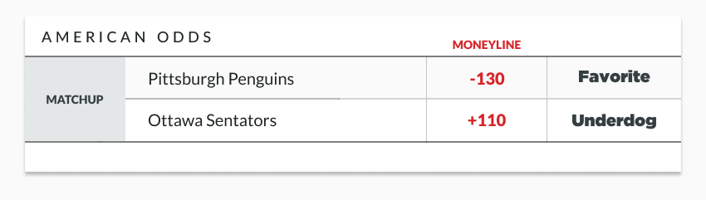 Probability and statistics are at the core of the sports betting phenomenon that we are experiencing. One of the simpler ways an interested party may be introduced to speculation on sporting events is a wager on which team will win a given game, also known as the Moneyline bet. To understand betting odds mathematically, they may be analyzed in the following way: for a team with minus odds (-n), which indicate a team favored by the sportsbook to win a given sporting event, divide 100 by the absolute value of the odds, |n|, and then multiply by the amount a user chooses to bet on the game to calculate the projected winnings. For example, with odds of -150 and a bet of $150, divide 100 by 150 and multiply by the bet amount to receive a payout of $100. For plus odds, which indicate an underdog, divide the odds (ABC) by 100 and multiply by the amount bet to determine the payout. For instance, with odds of +200, divide the absolute value of the odds—in this case |+200| by 100 and then multiply by amount bet by a user. To further understand, we can look at the example below for a hockey game.

If a better had $100 and an intent to bet, they could choose the Penguins or Senators Moneyline. If they choose the Penguins to win, they will win $\frac{100}{130}×\$100$ = $76.92. If they choose the Senators to win, they will win $\frac{110}{100}×\$100$ = $110. However, it is important to state that, should the better place their $100 and lose the bet, they lose the entire investment. There is less risk in betting on the Penguins—because they are projected to win the game—therefore a bet on the favored team yields less reward. There is higher risk in betting on the Senators in this scenario, yielding a higher reward for correct bet. While many more varieties of bets that can be placed sporting events other than just a Moneyline, this project will only focus on Moneyline bets.

Sportsbooks, sometimes referred to as oddsmakers, are responsible for setting Moneyline as seen in the example above. Considerations include recent team performance, current injury status of players, historical data about the sport, and more data to precisely choose odds to release to the public. If the oddsmaker does their job correctly, the odds will be balanced so that their employer, typically called a sportsbook, generates a profit from the losing bets, even after paying out rewards to those that won. After the odds are initially set by the oddsmakers, the odds are continuously updated, primarily determined by the public bets against the initially provided odds. If many bets are taken on one side, the odds will shift in that team’s favor. Taking the above example again, if most bettors took the Senators’ Moneyline, they might become favorites to win, flipping the odds between the two teams. This natural process rebalances the odds, continuing to generate profits for the sportsbooks. While this project does not promote games of chance, we hope to use the methods from this class to assess the odds provided by a sportsbook and make sequential decisions on whether to bet for or against a given sports team throughout a season. The goal of this project is to create a model that will accrue wins against oddsmakers. We will focus on college football, taking our model week by week through a season to predict the top few most likely winners for a given game week.

To do so, we hope to take advantage of the publicly available datasets available on college football. Websites like *collegefootballdata.com* allow us to access the Moneyline odds for almost all NCAA football games from a given season (CollegeFootballData.com, n.d.). With resources such as this, statistics for players, teams, coaching staffs, and more are available to iterate on ideal betting policies. As each game week is completed, the model can be updated with new information to make the decision for the next week.

The problem can be framed as a Markov Decision Process, where actions are bets on teams, states are the weeks of the season, and rewards are the results of bets. The state evolves weekly, and reinforcement learning could be used to adapt as the season progresses. Expected utility for each bet is calculated based on odds from available data, potentially covering every NCAA Division I game. We may narrow the scope to specific teams if necessary and explore different risk aversion levels.

References

(n.d.). Retrieved from CollegeFootballData.com: https://collegefootballdata.com/

Fayerman-Hansen, S. (2024, September 6). *The Best Algorithms for Sports Betting: A Guide to Making Informed Decisions*. Retrieved from Responsible Gambler: https://rg.org/guides/sportsbetting-guides/sports-betting-algorithms